ONLINE SHOPPING APPLICATION

MEESHO

# A REPORT

# BY RAMAN CHAUDHRY

**Table of Content**

**1. Introduction**

1.1 Overview

1.2 Need of Application

1.3 Scope

1.4 Platform Specification – Deployment

**2. System Requirement Analysis**

2.1 Specific Requirement

2.2 System Feasibility

2.2.1 Economic Feasibility

2.2.2 Behavioural Feasibility

**3. System Analysis**

3.1 ER Diagram

3.2 Data Flow Diagram

3.3 Use Case Diagram

3.4 Class Diagram

3.5 Object Diagram

3.6 Package Diagram

3.7 Deployment Diagram

**4. Design**

4.1 Design Goals

4.2 Architectural Design

4.3 Procedural/Modular Approach

4.3.1 Shop Product Module

4.3.2 Product Description Module

4.3.3 Cart Details Module

**5. Implementation**

5.1 Database Design and Implementation

5.2 User Design and Interface

**6. Testing**

6.1 Unit Testing

6.2 Integration Testing

6.3 Validation Testing

**7. Result**

**8. Conclusion**

**1. Introduction**

**1.1 Overview**

Meesho App, is an online reatailer store platform available on both Google Play Store and IOS App Store, which allows anyone to start their businesses with zero investment. It is one of the largest social commerce platforms, especially in India in which anyone can start their online business.

All a user needs to do is resell Meesho's products to your contacts. The application solely constitutes women entrepreneurs, housewives, college students, shop owners, beauticians, wholesale traders, or anyone looking for a part-time job or for a way to start their online business.

It provides a vast platform for sellers to sell their product widely all over India

The Meesho appcan also be used by sellers looking for a platform to sell their products. Small businesses and individuals selling handmade products can benefit from this app. Apart from this, users can also resell products from the Meesho products listto people from their contacts. The Meesho supplier panelconsists mainly of women entrepreneurs, especially housewives, beauticians, small business and shop owners, wholesale traders, and college students who are looking for part-time jobs and other employment opportunities.

# **1.2 Need for Application**

**Online shopping** is a form of electronic commerce which allows consumers to directly buy goods or services from a seller over the [Internet](https://en.wikipedia.org/wiki/Internet) using a web browser or a mobile app. Consumers find a product of interest by visiting the [website](https://en.wikipedia.org/wiki/Website) of the retailer directly or by searching among alternative vendors using a shopping search engine, which displays the same product's availability and pricing at different e-retailers.

A search engine that provides an easy and convenient way to search for products specific to their needs. The search engine would list a set of products based on the search term and the user can further filter the list based on various parameters

. A typical online store like Meesho enables the customer to browse the firm's range of products and services, view photos or images of the products, along with information about the product specifications, features and prices Also It will provide the users an interactive and friendly environment so that the user can go through a wide variety of products.

The Meesho also ensure to provide the best user experience and customer service by making end to end communication with user.

**1.3 Scope**

* It provides the searching facilities based on various factors like Shopping , Payment Bills, Pricing, and on other Factors.
* It tracks all the information of customer product, bills, etc.
* Provide Interactive interface through which a user can interact with different areas of application easily.
* The system can be used to allow the users to create accounts and save products in to wish list.
* Users can have multiple shipping and billing information saved and can be able to access in future.
* Feedback mechanism, so that customers can give feedback for the product or service which they have purchased. Also facility rating of individual products by relevant customers.

**1.4 Platform Specification – Deployment**

1. **Hardware Specification**

Processor:Dual Core

RAM:2 GB Hard Disk:320 GB

NIC:For each party

1. **Software Specification**

.Operating System: Windows7 Ultimate which supports networking.

JAVA development toolkit.

**2. System Requirement Analysis**

**2.1 Specific Requirements**

Registration: If customer wants to buy the product then he/she must be registered, unregistered user can’t go to the shopping cart.

Login: Customer logins to the system by entering valid user id and password for the shopping.

Changes to Cart Changes: to cart means the customer after login or registration can make order or cancel order of the product from the shopping cart.

Payment: In this system we are dealing the mode of payment by Cash. We will extend this to credit card, debit card etc in the future.

Logout : After ordering or surfing for the product customer has to logout.

Report Generation : After ordering for the product, the system will sent one copy of the bill to the customer’s Email-address and another one for the system data base.

**2.2 System Feasibility**

1. **Economic Feasibility**

The online application is online feasible as it requires only a computer with minimal specification and internet connection . The user can simply use it and can surf with a stable network connection through the application.

1. **Behavioural Feasibility**

A user can simply go through the whole application without a special technical guidance and the system is also user friendly so it helps the user to provide with better experience.

**3. System Analysis**

Analyzing the requirements and functionality of the web application, I had two important diagrams by the end of the analysis phase. They are the ER diagram and data flow diagram which were the basis for finding out entities and relationships between them, the flow of information.

**3.1 ER Diagram**

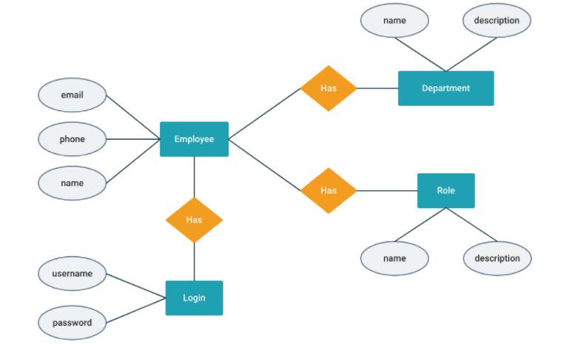

**3.2 Data Flow Diagram**

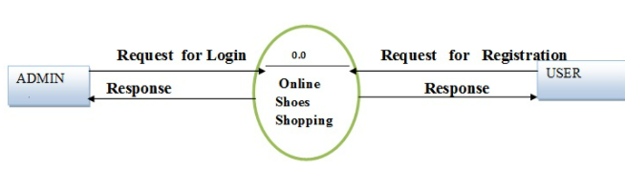

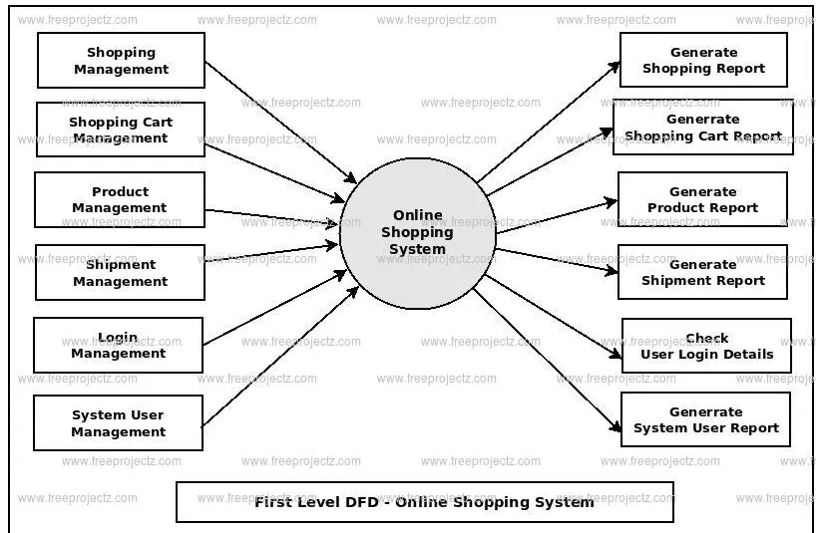

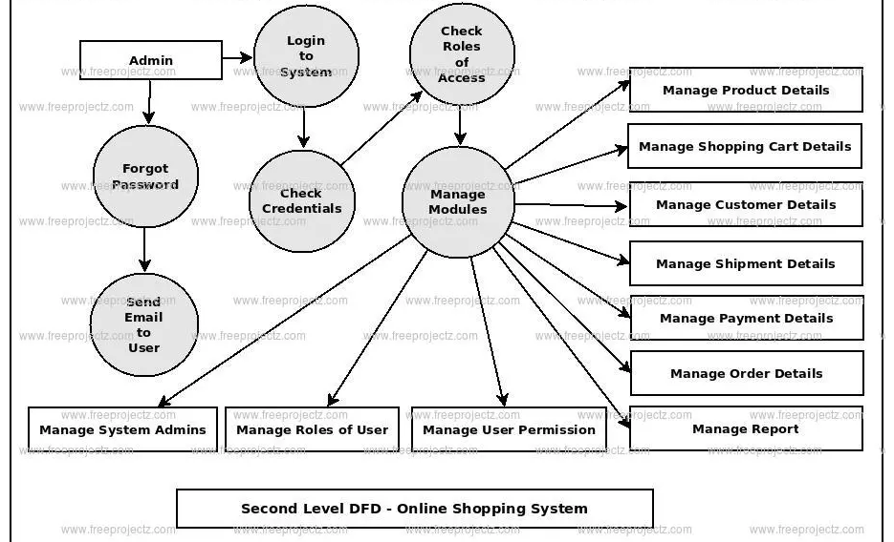

3.3 Use Case Diagram

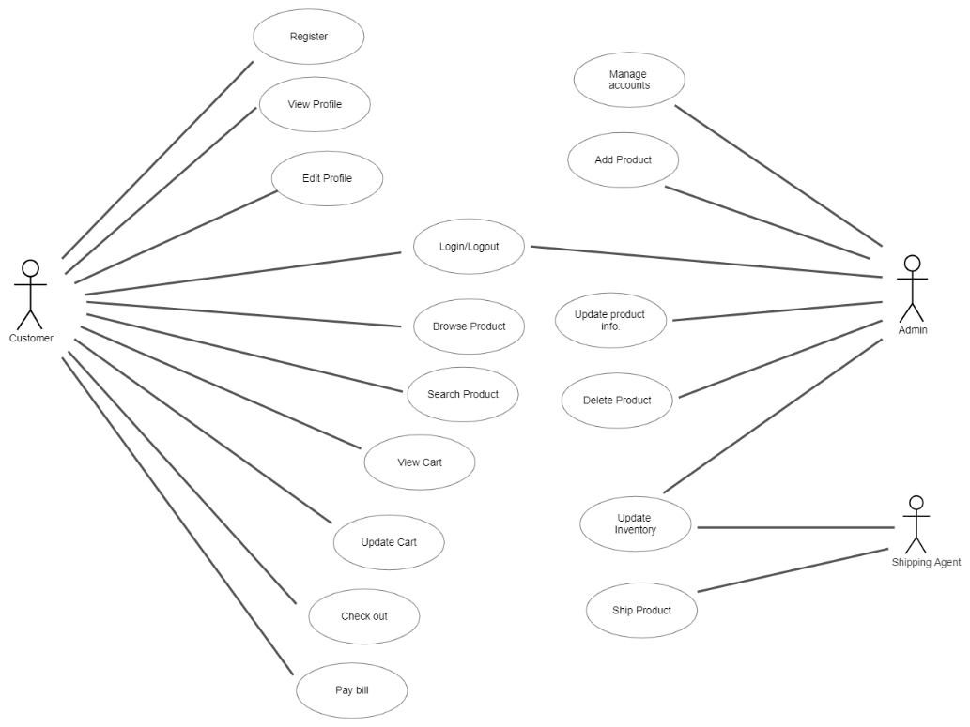

3.4 Class Diagram

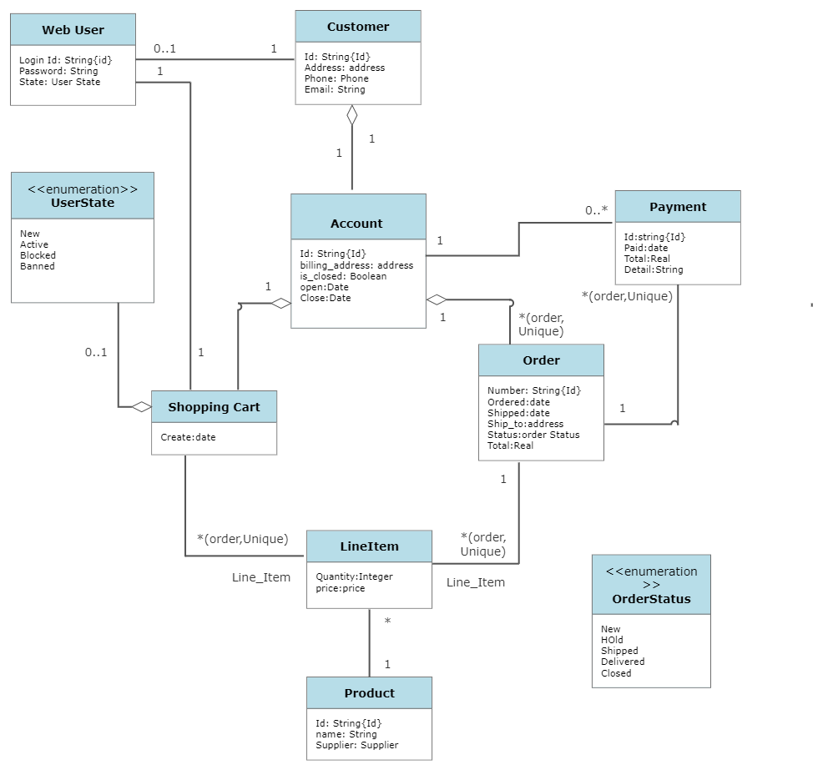

3.5 Object Diagram

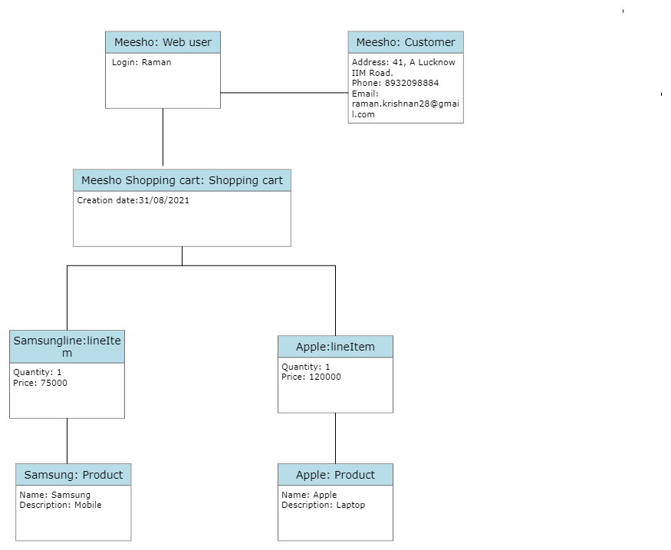

3.6 Package Diagram

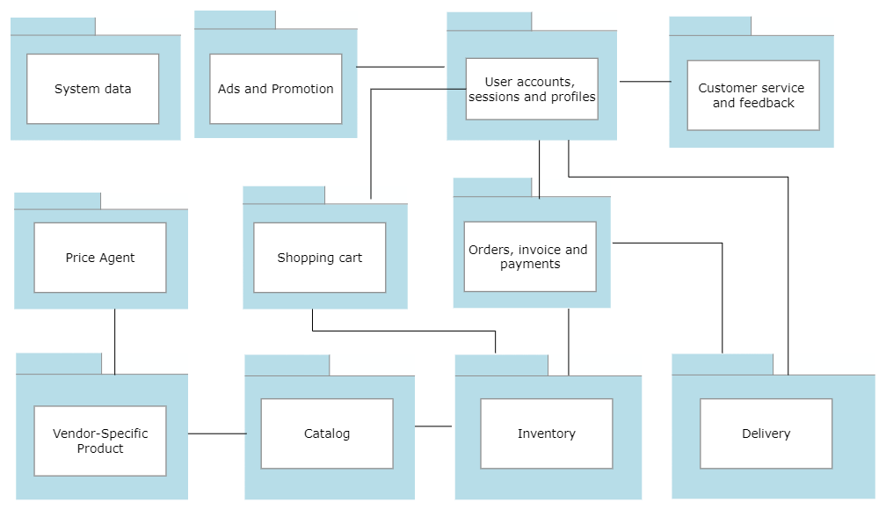

3.7 Deployment Diagram

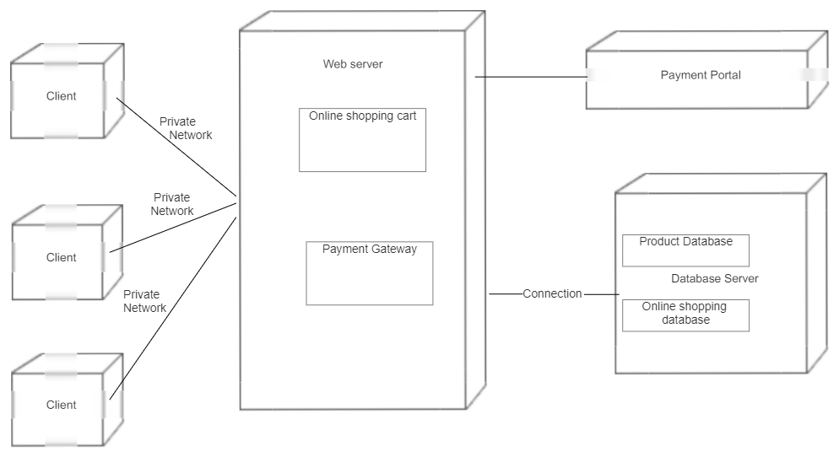

**4. Design**

4.1 Design Goals

• The design of the web application involves the design of the forms for listing the products, search for products, display the complete specification for the product, and design a shopping cart that is easy to use.

• Design of an interactive application that enables the user to filter the products based on different parameters.

• Design of an application that has features like drag and drop etc.

• Design of application that decreases data transfers between the client and the server

4.2 Architectural Design

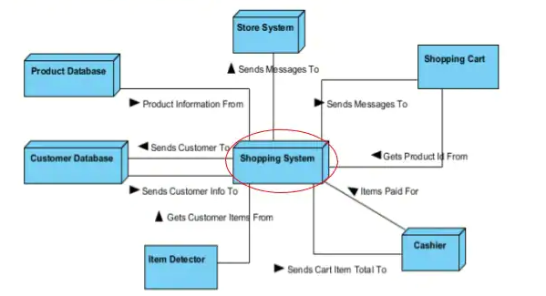

Description of Architectural Design

In this we can observe that system is collecting information from the customer database and afterwards its sending message to shopping cart and in reverse getting the product information and the item detector sending customer items to the shopping system then the total cart item been sent to the cashier system which give the information of the items which have been paid and it is again sent to the shopping system and further it is also gets stored in the storage system.

**4.3.1 Shop Products Module**: This module starts when the user visits the home page or when a user searches for a product by entering a search term. This part of the application includes displaying all the products that are available or the products that match the search term entered by the user. The user can then filter these products based on various parameters like manufacturer, product type, operating system supported or a price range.

**4.3.2 Product Description Module**: This module starts when a user visits the product description page. A user can view various images of the product of different sizes. The use can see an enlarged image in a popup window. The user can view the complete specification of the product like its features, operating system supported, system requirements etc.

**4.3.3 Shopping Cart Module**: This module starts when the user views the shopping cart. All the products that have been added to the shopping cart by the user are listed along with their price and the quantity. The total price of all the products added to cart is displayed. A user can edit the quantity of each product or remove the product from the shopping cart. A user can remove the product from the cart by clicking a button or by dragging the product and dropping it outside the cart. The total price changes accordingly when a user edits the quantity of a product or when a product is removed from the cart.

**5. Implementation**

**5.1 Database Design and Implementation**

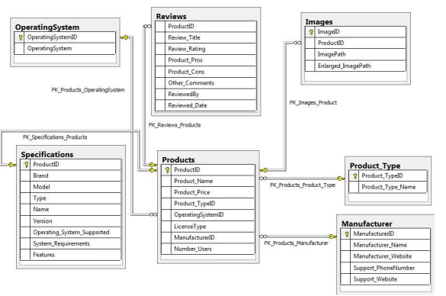

**5.2 User Interface Design and Implementation**

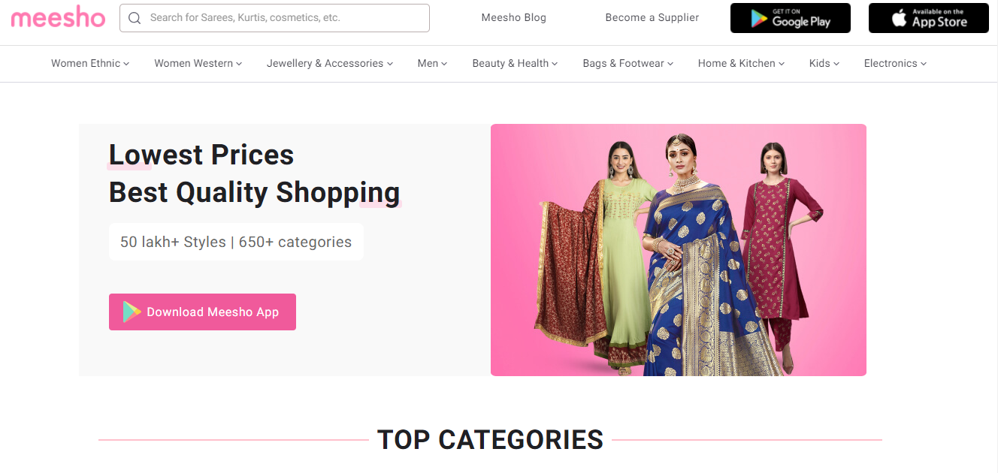

The above figure shows the product page.

The user can search through the search bar through different products and also there is drag and drop option in the dashboard which is provided with different options. The user can see through a variety of Products.

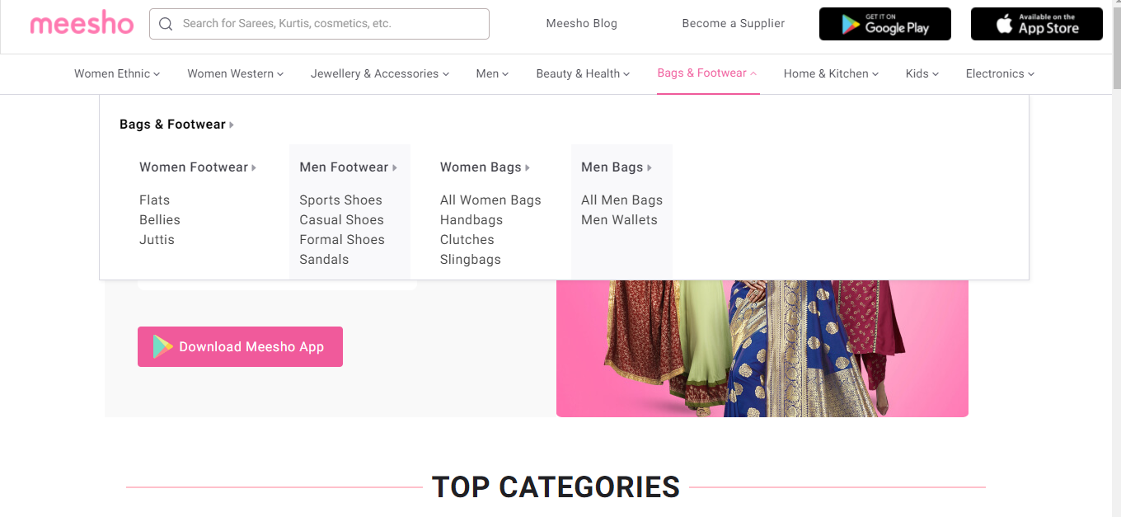

The above figure shows the drag and drop option of the website

**5.3 Technical Discussion**

 This is the Bengaluru based shopping platform who is helps in the both resellers and emerging brands. With the help of social media in increasing their business. It has raised a funding of about $50 during the series C funding.

 The round was led by new investors Shunwei capital, RPS ventures and DST partners. The same time, the proud investers SAIF partners, venture highway, Y combination and Sequoia india also participated in it.

There is many features in Meesho app who is make a best. There are available two option in Meesho app for users. Customer can through either of the options of online payment and cash on delivery. Many large shopping companies only pay at the time of order. So the users the use Meesho app for cash on delivery.

Also it was decided initially to have a drop down list for price range and the user could select a price range from the ranges available. But this would limit the user’s ability to filter the products based on different price ranges. Instead providing two text fields so that the user can enter their price range would give them more flexibility.

The app available in the seven language. At the same time, about 30-40 percent traffic in their daily usage comes from non-english speaking audience only.

The Meesho app products can be filtered based on various parameters like Manufacturer, Product Type, Operating System supported etc. Initially it was decided to have the various list items predefined.

**5.4 How it works?**

The Meesho app provides a cost effective option for selling goods as no start-up investment is required by the sellers. Meesho is an online marketplace that connects sellers and resellers to relevant customers with the help of business men's social media space.

In the words of Google "Meesho is a business for empowerment; the innovative app that enables you to work from home, Meesho provides products at wholesale prices that you can resell to earn a profit and commission."

Basically, anyone willing to work on the Meesho platform shall have to share the products listed on Meesho through their various social media handles within their network of friends. If any of the products get sold, they get to earn an additional profit margin for it.

The willing sellers/ resellers need to follow the below-mentioned steps to get associated and earn with Meesho reselling and shopping app:

1. The entrepreneur/supplier/seller needs to register their business/ individual details on the Meesho application.

2. A virtual store is created on it.

3. Next they need to list their products on the virtual store along with some images of the product description, and the selling price

4. Meesho app user browses the app and if he finds an appealing product he shares it further. This way he becomes a Meesho reseller of the product.

5. The reseller shares the images of this particular product in his or her network through social media platforms like WhatsApp Facebook and Instagram etcetera with a message stating the product details and the price (usually at a price higher than the quoted selling price by the original seller)

6. If anyone from the network wishes to buy the product they shall have to send a message to the app user regarding the same. This way this person shall become the ultimate end-user of the product.

7. The user of the Meesho App shall process the order further to the seller by stating his or her additional profit margin and shall list the address of the end-user and thereby placing the order.

In case the sellers directly get a customer, the additional profit margin of resellers is saved.

8. After the seller accepts the order and it is processed for delivery to Meesho. Meesho shall pick up the order and deliver it to the end-user within the specified time at an Invoice price as quoted by the reseller.

**6. Testing**

Software testing is the process of evaluating and verifying that a software product or application does what it is supposed to do. The benefits of testing include preventing bugs, reducing development costs and improving performance.

**6.1 Unit Testing**

Unit testing emphasizes the verification effort on the smallest unit of software design i.e.; a software component or module. Unit testing is a dynamic method for verification, where program is actually compiled and executed. Unit testing is performed in parallel with the coding phase. Unit testing tests units or modules not the whole software.

**6.2 Integration Testing**

In integration testing a system consisting of different modules is tested for problems arising from component interaction. Integration testing should be developed from the system specification. Firstly, a minimum configuration must be integrated and tested.

**6.3 Validation Testing**

It provides final assurances that software meets all functional, behavioral & performance requirement. Black box testing techniques are used. There are three main components –

- Validation test criteria (no. in place of no. & char in place of char)

- Configuration review (to ensure the completeness of s/w configuration.)

- Alpha & Beta testing-Alpha testing is done at developer’s site i.e. at home & Beta testing once it is deployed.

**7. Result**

This application is best use for e-commerce selling and retailing app as it provide a GUI based interface which is user friendly and also It is easy to use and going through a lot of different products at a same time being a part of shopping make it more reliable for customers.

**8. Conclusion**

The meesho app is a web based e commerce site which allow users to search, surf , selecting, and viewing different products at a same time and all in one place. As it provide suggestion to the user based on their search and on previos orders and surfing which they have done using this it provide a better recommendation for them. Also it allow user to write the review about a product and also to read them and also to read them. The app is a complete package of a perfect shopping site with a great customer service and platform.